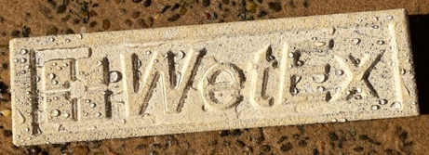

WetEx™ Pearl — the energy-saving mechanism

Think of a porous wall as a dry thermal matrix containing millions of tiny air spaces.
When the wall is dry:
Dry pores → low heat transfer → higher thermal resistance
When water enters those pores:
Water-filled pores → higher heat transfer → lower thermal resistance
Water conducts heat far more effectively than the still air normally contained within the pores. As moisture increases, the effective thermal conductivity of many building materials increases greatly.
For example, in a brick case, increasing moisture from 1% to 5% by volume increases thermal conductivity by about 20%, reducing the R-value correspondingly.
It also shows that the effect can be much larger in some highly porous insulation materials. One study found mineral wool's thermal conductivity increased from about 0.041 W/m·K dry to 0.10–0.14 W/m·K at relatively modest moisture contents, and much higher when saturated.
So the fundamental proposition for WetEx™ Pearl is:
WetEx™ Pearl does not add insulation to the wall. It protects the insulation and porous mineral structure from losing thermal performance through water absorption.
"Moisture increases the thermal conductivity of many porous building materials. As moisture enters the pore structure, thermal resistance can decrease, reducing the thermal efficiency of the building envelope. WetEx™ Pearl reduces capillary water uptake, helping the substrate remain drier and retain its designed thermal performance."

1. What WetEx™ Pearl actually does
A conventional waterproof coating tries to create a barrier on the surface.
WetEx™ Pearl works differently.
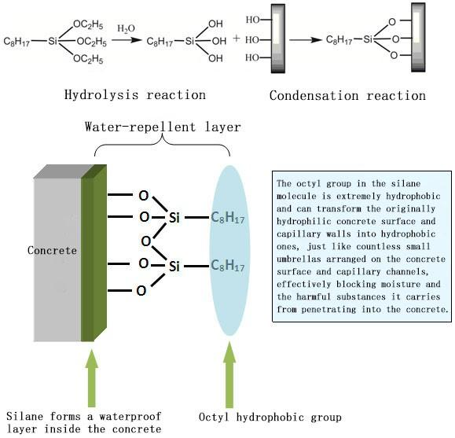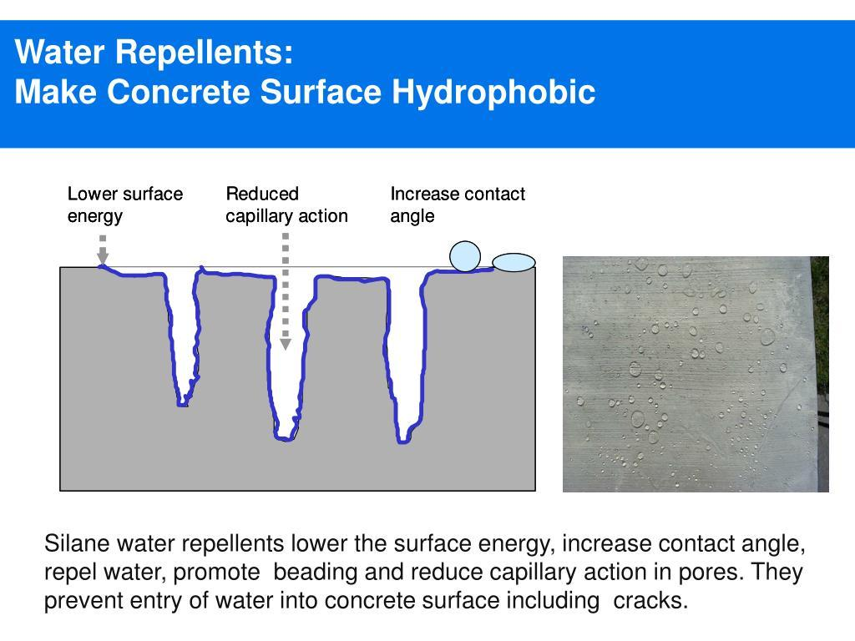

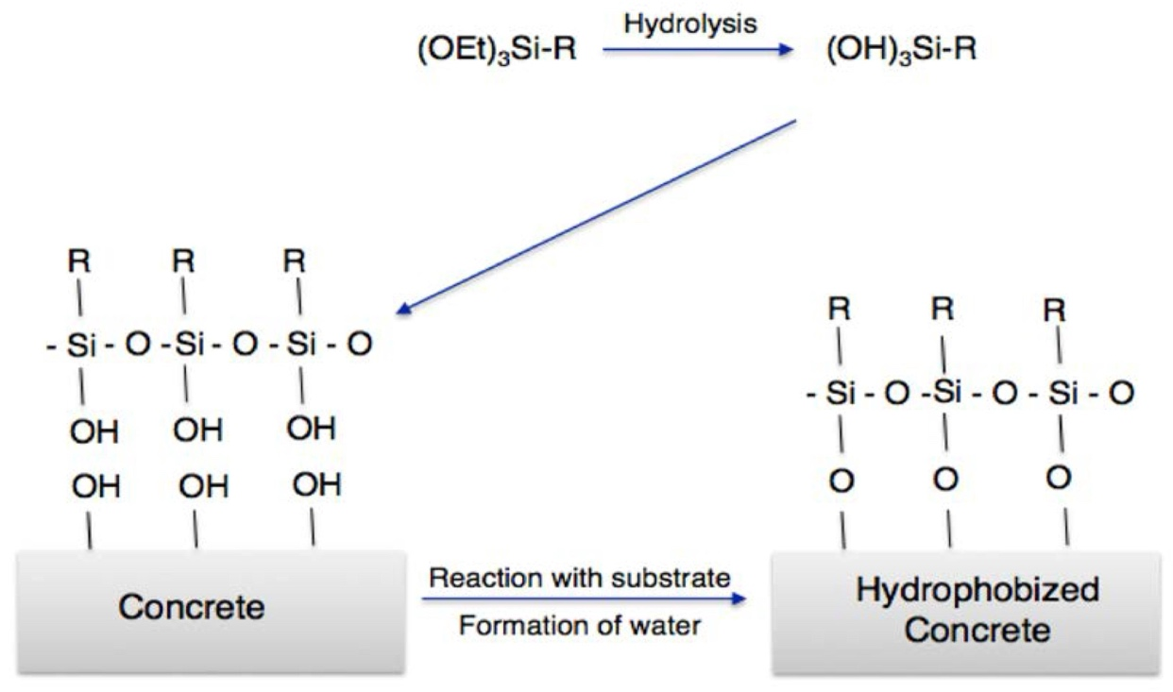

The diluted product penetrates the capillary network of the substrate.
The silane/siloxane components become deposited on the internal porous surfaces and chemically react, creating a hydrophobic internal surface.
In simplified terms:
Before treatment –
substrate can hold water for a long time even after a sealer is applied; a wet substrate makes a perfect conductor in transferring energy both ways .
After WetEx™ Pearl –
substrate can not hold water (evaporation) even after a WetEX™Pearl is applied; The hydrophobic porous walls repel the water and the capillary uptake is greatly reduced. Embedded water can evaporate at the same time.
This is why the product can produce the characteristic "pearl" or beading effect without filling the pore structure.

2. Why keeping the wall dry saves energy
There are actually three mechanisms involved.

A. Lower thermal conductivity
This is the most important mechanism.
A dry porous material contains air within its pore structure. When water replaces that air, the effective thermal conductivity increases.
Therefore:
Dry wall → higher R-value
Wet wall → lower R-value
This relationship is material-specific. It specifically notes that the apparent thermal conductivity of insulation increases with moisture content, and that the magnitude depends on material, temperature, moisture content and moisture distribution.

3. Wet walls also have a moisture-management problem
There is another important effect.
A wet facade isn't simply a "wet piece of insulation."
It becomes part of a heat + moisture transport system.
Water can:
- conduct heat through the material;
- move through capillaries;
- evaporate from the surface;
- condense elsewhere;
- transport heat through moisture movement;
- change the thermal properties of the material.
Recent research confirms that moisture-dependent thermal conductivity materially affects building-energy calculations. This is particularly important in porous walls.

4. WetEx™ Pearl helps the wall stay thermally stable
The easiest/strongest way to describe the energy benefit:
Rain protection → less water absorption → lower moisture content → lower thermal conductivity → greater retained thermal resistance → lower heating/cooling demand.

5. How much energy can a dry wall save?
There is no single percentage.
This is extremely important.
Suppose, purely as an example, that a particular wall has:
Dry thermal conductivity: λ = 0.40 W/m·K
and moisture exposure increases it by 20%:
Wet λ = 0.48 W/m·K
For a 105 mm wall:

Dry
R = 0.105 / 0.40
R = 0.263 m²·K/W

Wet
R = 0.105 / 0.48
R = 0.219 m²·K/W
That is approximately a 17% reduction in the wall's thermal resistance.
But importantly, that doesn't mean the building's total energy consumption falls by 17%.
The wall is only one part of the building's total heat transfer.

6. A better way to calculate the WetEx™ Pearl benefit

"Retained Thermal Performance"

For example:

Untreated wall
Rain exposure
↓
Capillary water absorption
↓
Increasing moisture content
↓
Increasing thermal conductivity
↓
Decreasing R-value
↓
Higher heating/cooling load

WetEx™ Pearl treated wall

Rain exposure
↓
Hydrophobic pore structure
↓
Reduction in capillary water uptake*
↓
Lower moisture accumulation
↓
Lower increase in thermal conductivity
↓
Better retention of designed R-value
↓
Potential reduction in heating/cooling demand
* for the relevant substrate/test method.

7. This becomes particularly interesting with insulation
This is where I think WetEx™ Pearl can become much more strategically important.
Imagine a wall consisting of:
External render → masonry → insulation → internal lining
The insulation may have an excellent declared R-value when dry.
But if moisture enters the wall assembly, its actual thermal conductivity changes.

Research on hydrophobised masonry walls found that hydrophobisation improves hygrothermal performance when combined with insulation, and specifically examined the additional energy savings resulting from hydrophobic treatment.
So WetEx™ Pearl can be positioned as a thermal-performance protection layer, rather than simply a waterproofing chemical.

8. WetEx™ Pearl + TDC™ thermal dynamic coating

a very interesting system
The two technologies perform different jobs.

WetEx™ Pearl

Controls moisture entering the substrate
↓
Keeps mineral substrate drier
↓
Helps preserve thermal performance
↓
Reduces water-related degradation

HYDRO™ TDC

Controls heat entering/leaving through the external surface
↓
Reflective/thermal-dynamic surface behaviour
↓
Reduces heat absorption
↓
Reduces surface temperature/heat flow

Together:

WetEx™ Pearl = moisture management
TDC™ = thermal management

9. There is also a major workability benefit
This is often overlooked.

WetEx™ Pearl isn't just about long-term protection.
It can become an important substrate-conditioning step.
A controlled hydrophobic impregnation can:
- reduce uncontrolled water uptake;
- reduce rain penetration;
- reduce moisture cycling;
- reduce salt/water transport;
- improve façade durability;
- reduce biological growth conditions;
- make subsequent maintenance easier;
- provide a more stable substrate environment.
But there is an important qualification:
Therefore, for your WetEx™/TDC™ system, a validated sequence can be:
Option A
Substrate
→ WetEx™ Pearl
→ TDC™ coating
Option B
Substrate
→ TDC™ Surface treatment
→ WetEx™ Pearl as final hydrophobic treatment
depending on the specific system. (A pull-off/adhesion test should be done)

10. The "dry building" argument is bigger than energy
The strongest commercial argument for WetEx™ Pearl is actually:

Dry buildings perform better for longer.

A dry mineral wall generally has:

Better thermal performance

Less moisture damage

Less freeze/thaw risk in relevant climates

Less salt transport

Less biological growth potential (mould needs H2O)

Lower maintenance

Better coating/render durability

More stable indoor humidity

Better building performance

11. A strong WetEx™ Pearl technical statement
WetEx™ Pearl — Moisture Protection That Helps Preserve Thermal Performance
WetEx™ Pearl is a penetrating silane/siloxane hydrophobic impregnation designed to reduce capillary water absorption in porous mineral building materials.
Unlike film-forming waterproofing coatings, WetEx™ Pearl penetrates the pore structure and modifies the internal pore surfaces, creating a hydrophobic environment that strongly resists liquid-water penetration while maintaining vapour permeability.
By reducing water absorption, WetEx™ Pearl helps maintain a lower moisture content within the building envelope. This is important because moisture can increase the thermal conductivity of porous building materials and insulation, reducing their effective thermal resistance.
WetEx™ Pearl therefore does not function as insulation itself. Its energy-efficiency role is to help protect the thermal performance of the insulation and mineral substrate already present in the building envelope.
The result is a building envelope that is better protected against rain and moisture, more thermally stable, easier to maintain and potentially more energy efficient over its service life.

The simple story

WATER IN → THERMAL PERFORMANCE DOWN
WATER OUT → THERMAL PERFORMANCE PRESERVED
WetEx™ Pearl → keeps the wall drier → helps the wall retain its designed thermal performance.
This is a particularly good fit with the TDC™ technology platform: WetEx™ Pearl manages moisture; TDC™ manages heat; TDC™ Surfaces manages water ingress/protection at the surface. That gives you a genuine building-envelope system, rather than unrelated products.
For safety: Wear protective gear such as gloves and glasses when handling WetEx™Pearl. When spraying, avoid windy conditions and keep out of the reach of children.
Safety Directions
Keep out of reach of children. Avoid contact with eyes. In case of contact with eyes, rinse immediately with plenty of water. If swallowed, drink plenty of water and seek medical attention immediately.
WetEx™Pearl is non-flammable and non-toxic.
WetEx™Pearl coverage: 5-20m2 per litre (depending on substrate)
WetEx™Pearl concentrate has a shelf-life of up to 1 year when stored in a cool, dry, well-ventilated location, away from direct sunlight. Keep container(s) tightly sealed.
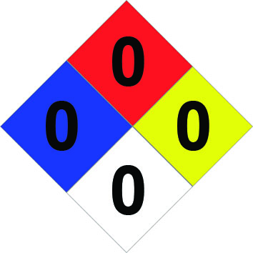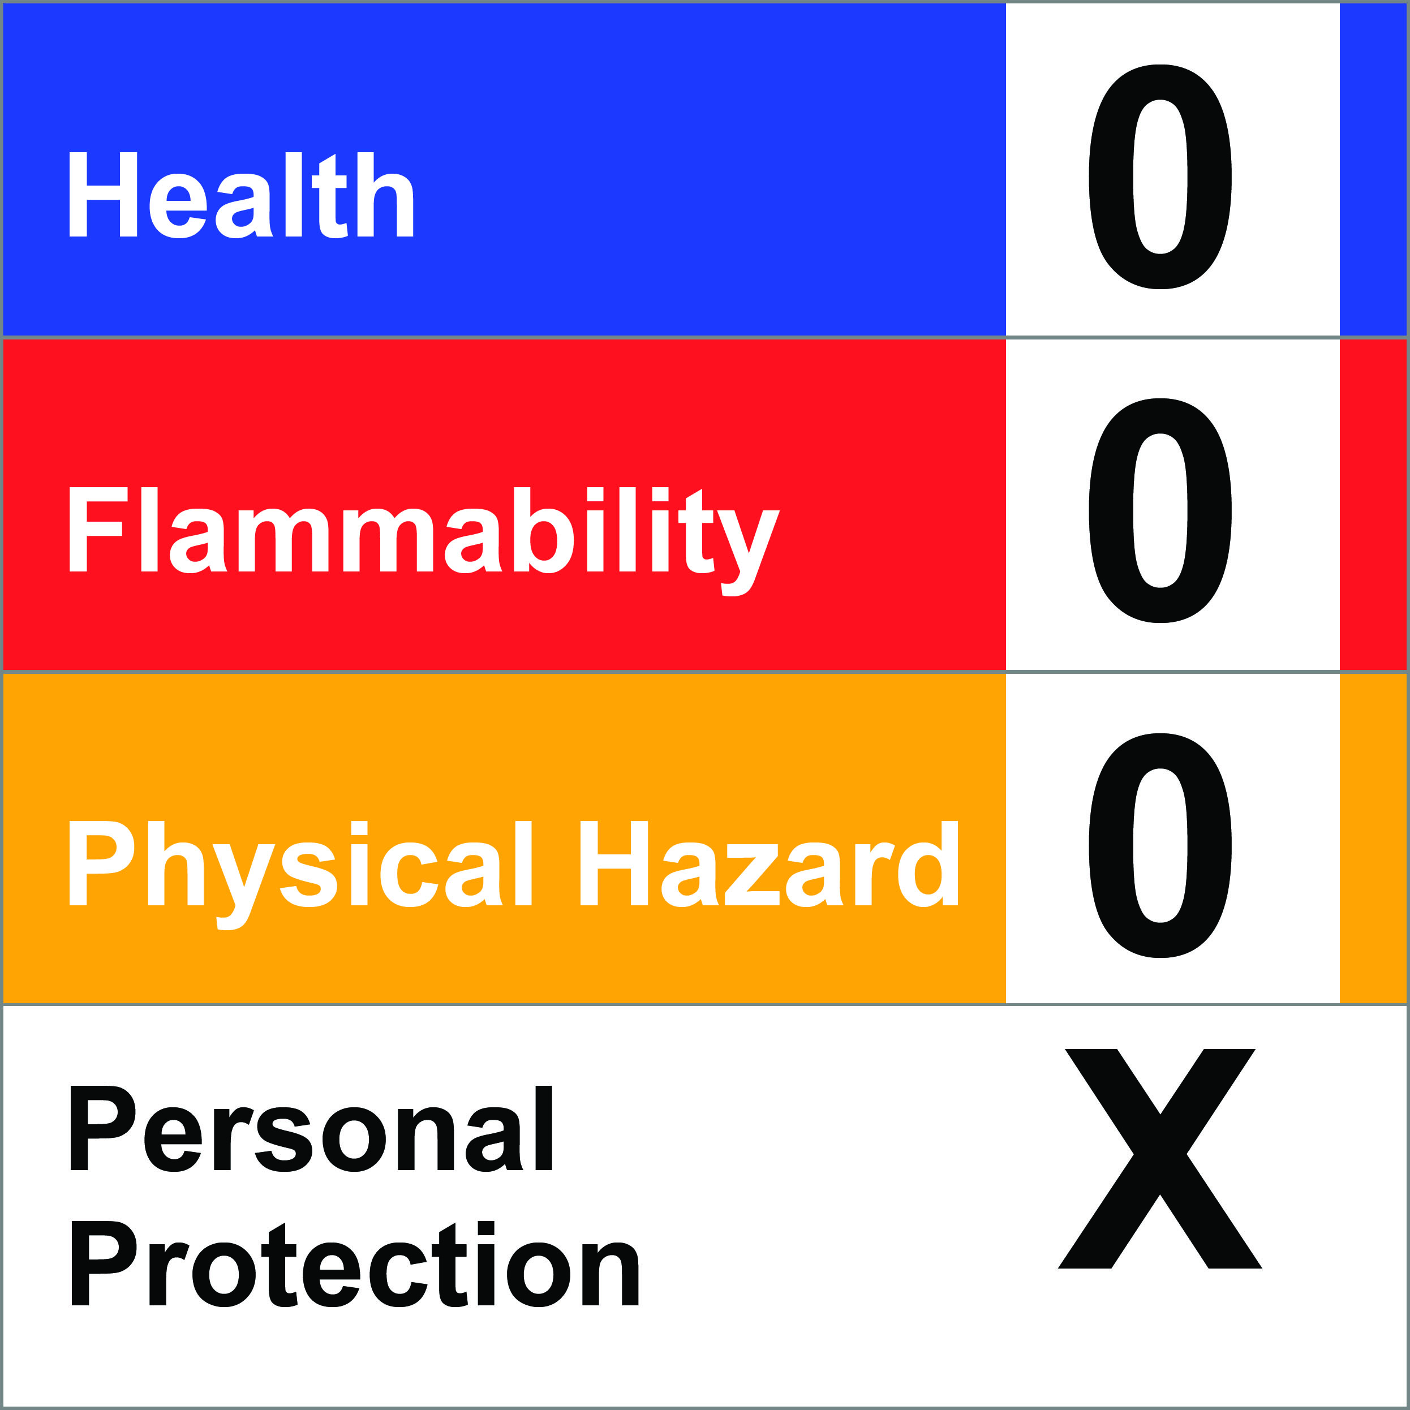
WetEx™Pearl is available in 20-litre cubes and in IBC volumes of concentrate.

fD warrants that the products manufactured by it shall be free from material defects and will conform to formulation standards and contain all components in their proper proportion. Should any of the products be proven defective, the liability to fD shall be limited to replacement of the material proven to be defective. fD MAKES NO WARRANTY AS TO MERCHANTABILITY OR FITNESS FOR A PARTICULAR PURPOSE, AND THIS WARRANTY IS IN PLACE OF ALL OTHER WARRANTIES EXPRESSED OR IMPLIED. User shall determine the suitability of the product for its intended use and assume all risks and liability in connection therewith.

